- \Operation\Monitoring, product presence in carton\Monitoring product presence in carton
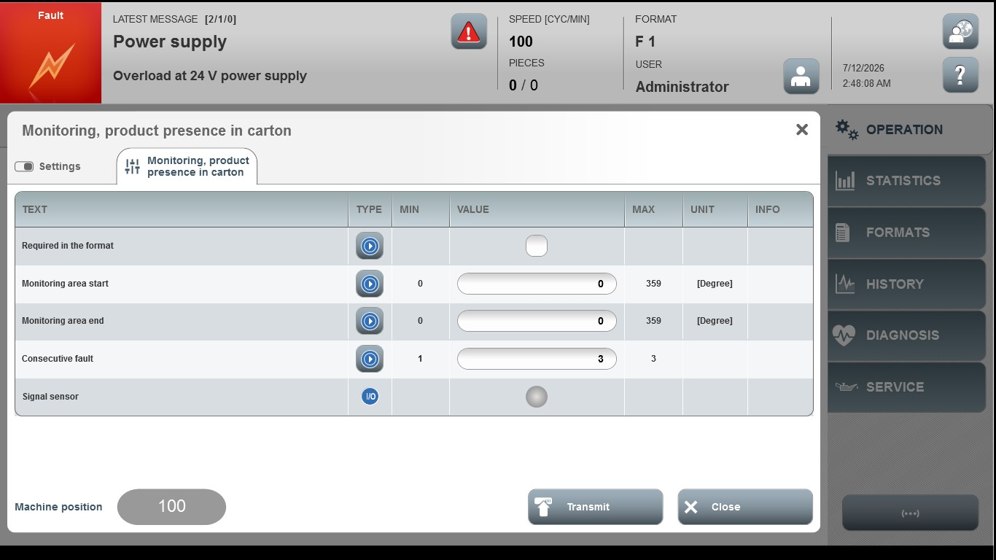

Acceptance criterion | Limits | Pass / Fail: Dev-No. | Date | Initials
Screen matches screenshot | N / A
Monitoring area start | 0…359
Monitoring area end | 0…359
Consecutive fault | 1 ... 3

